Microprocessors

Mammal and Bird Hardware Comparison
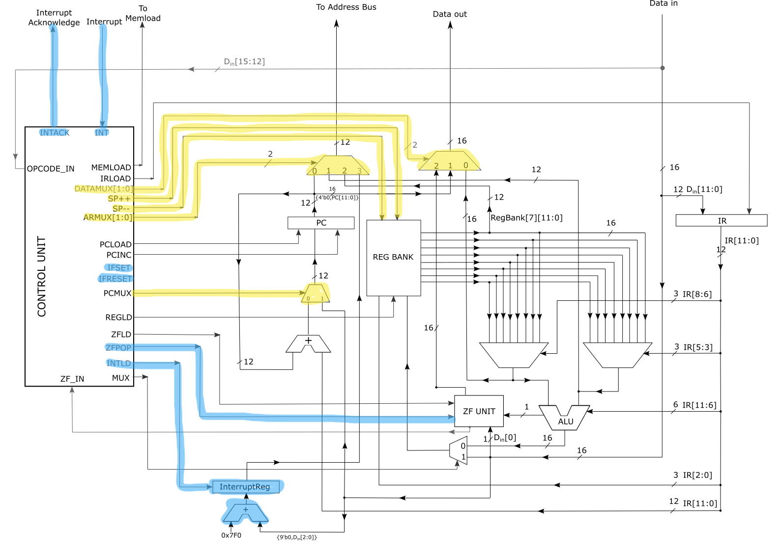
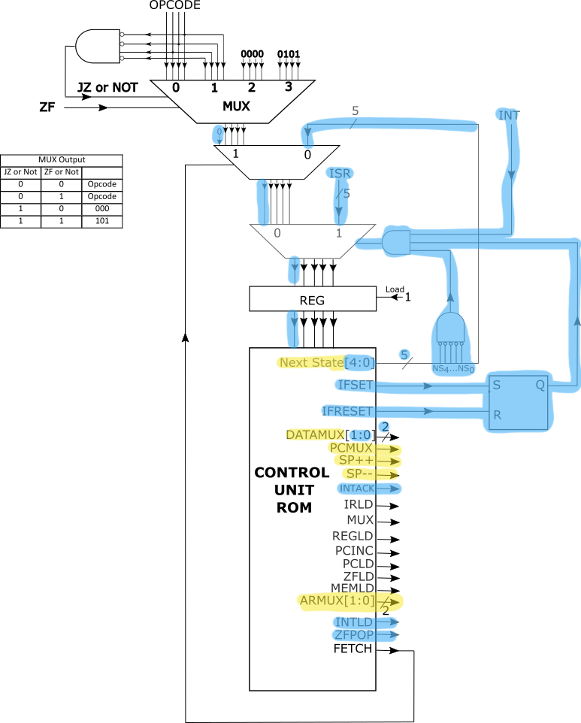

Mammal

Finite State Machine
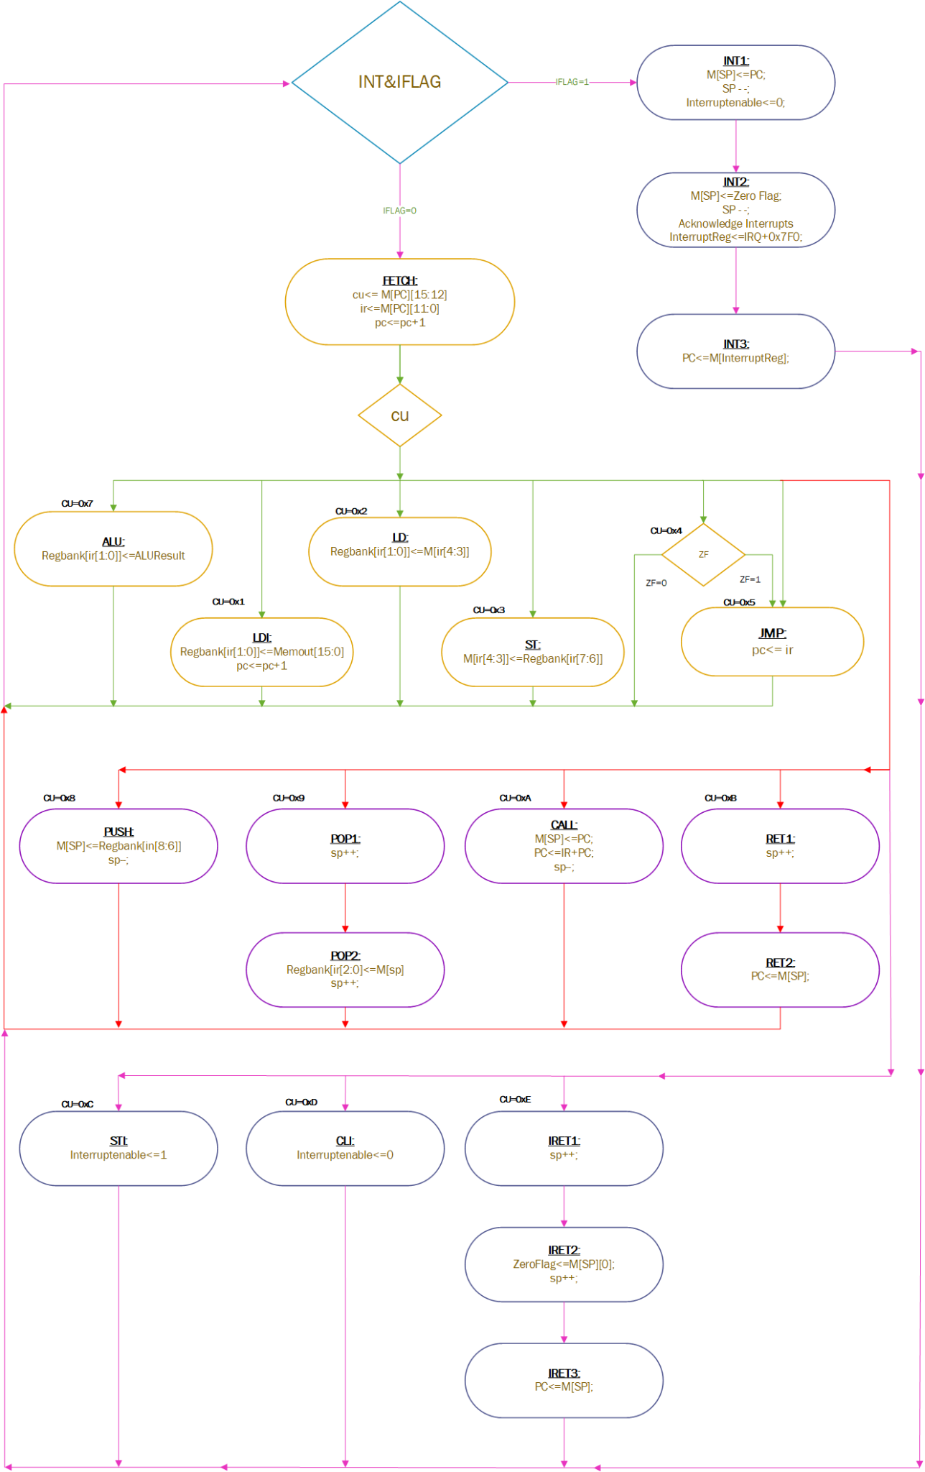

Control Signals
State | Signals
FETCH | FETCH, PCINC, IRLD
LDI | PCINC, REGLD, MUX
LD | ARMUX, MUX
ST | ARMUX, MEMLD
JMP | PCLD
JMPZ
ALU | REGLD, ZFLD
PUSH | ARMUX=2, MEMLD, SP–
POP1 | SP++
CALL | ARMUX=2, PCLD, MEMLD, SP++
RET1 | SP++
STI | IFSET
CLI | IFRESET
IRET1 | SP++
IRET2 | ARMUX=2, REGLD, SP++, MUX
IRET3 | ARMUX=2, PCMUX, PCLD
POP2 | ARMUX=2, MUX
RET2 | ARMUX=2, MUX, PCMUX
INT1 | ARMUX=3, DATAMUX, MEMLD, SP–, IFRESET
INT2 | ARMUX=3, DATAMUX=2, MEMLD, SP–, INTACK, INTLD, ZFPOP
INT3 | ARMUX=3, PCMUX, PCLD

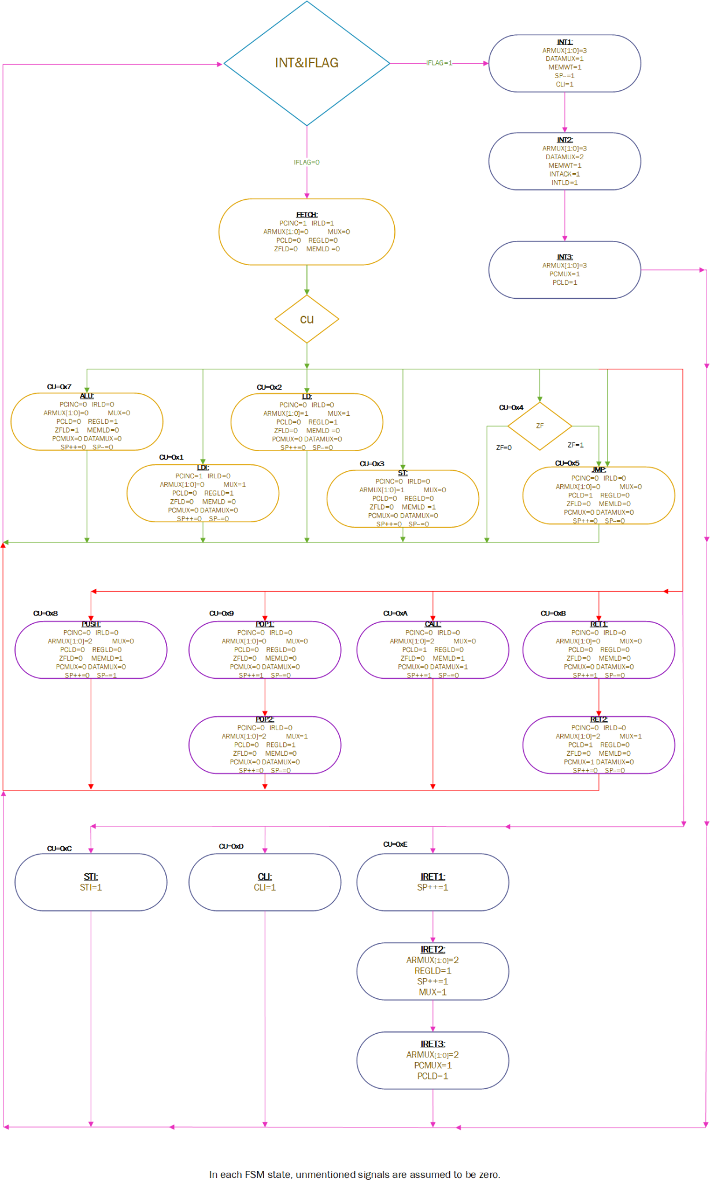
STI=IFSET, CLI=IFRESET

Hardware with Control Unit
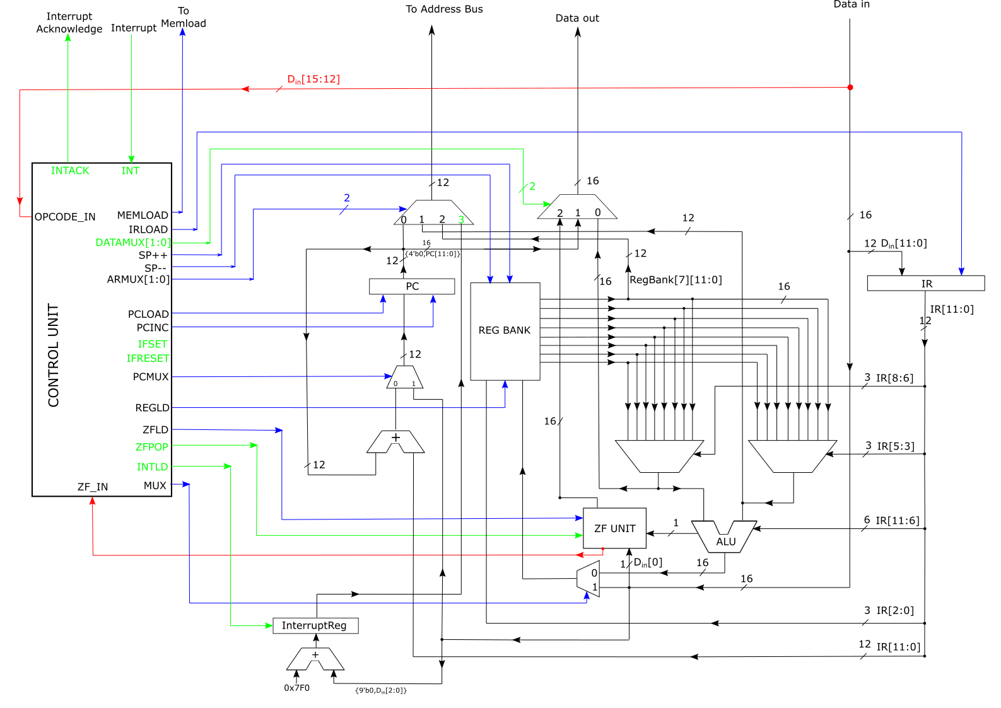

Control Unit
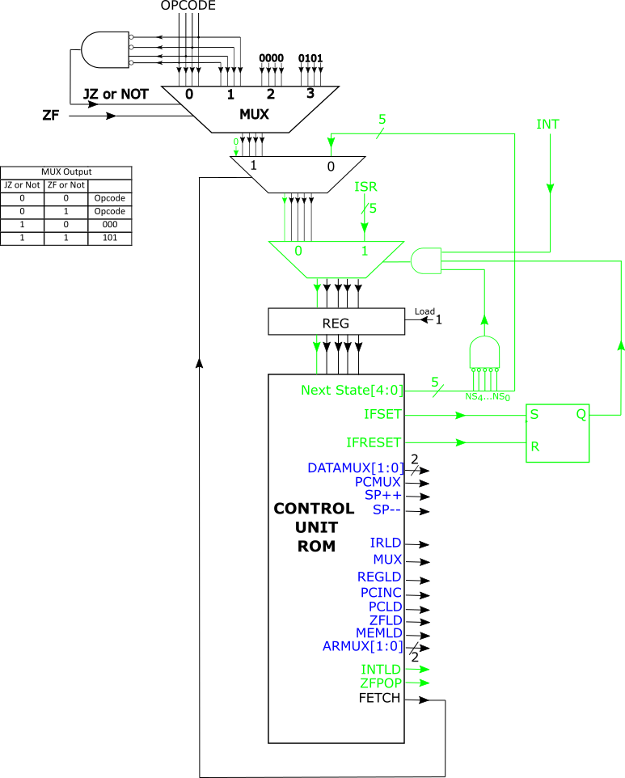

ZF Unit
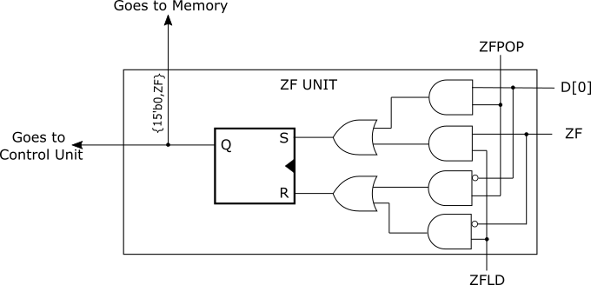

Hardware Design
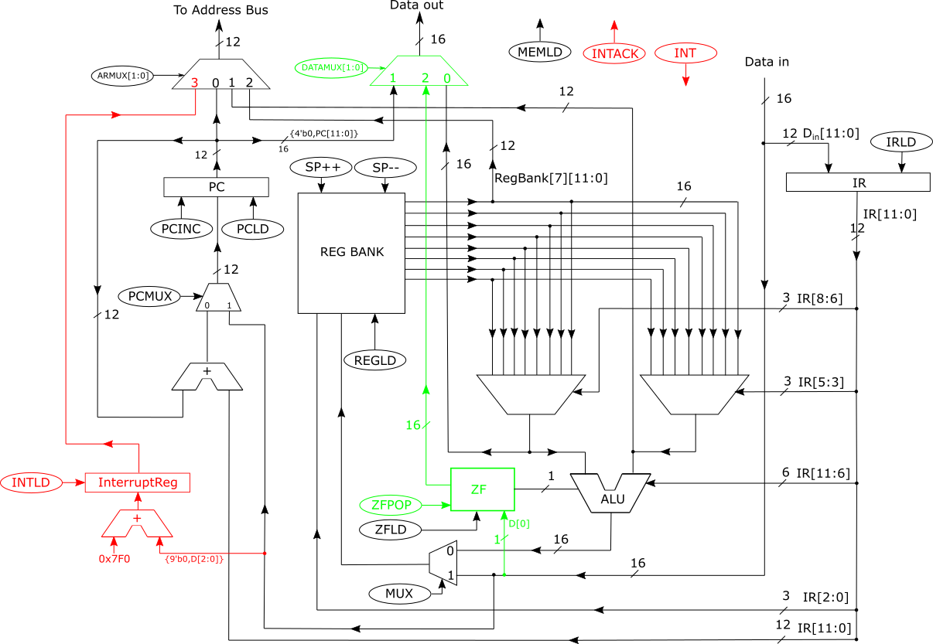

Microcode
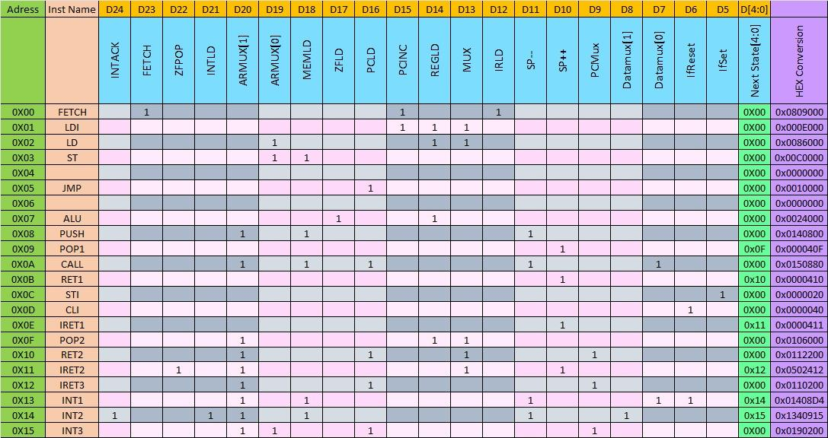

Address | OPCODE | INS | FETCH | DATAMUX(1) | DATAMUX(0) | PCMUX | SP++ | SP– | PCLD | PCINC | ARMUX(1) | ARMUX(0) | REGLD | ZFLD | MUX | MEMLD | IRLD | INTLD | ZFPOP | IFSET | IFRESET | INTACK | Next State | Hex Code
0 | 00000 | FETCH | 1 | 0 | 0 | 0 | 0 | 0 | 0 | 1 | 0 | 0 | 0 | 0 | 0 | 0 | 1 | 0 | 0 | 0 | 0 | 0 | 11111 | 102041F
1 | 00001 | LDI | 0 | 0 | 0 | 0 | 0 | 0 | 0 | 1 | 0 | 0 | 1 | 0 | 1 | 0 | 0 | 0 | 0 | 0 | 0 | 0 | 00000 | 0025000
2 | 00010 | LD | 0 | 0 | 0 | 0 | 0 | 0 | 0 | 0 | 0 | 1 | 1 | 0 | 1 | 0 | 0 | 0 | 0 | 0 | 0 | 0 | 00000 | 000D000
3 | 00011 | ST | 0 | 0 | 0 | 0 | 0 | 0 | 0 | 0 | 0 | 1 | 0 | 0 | 0 | 1 | 0 | 0 | 0 | 0 | 0 | 0 | 00000 | 0008800
4 |  |  |  |  |  |  |  |  |  |  |  |  |  |  |  |  |  |  |  |  |  |  | 00000 | 0000000
5 | 00101 | JMP | 0 | 0 | 0 | 0 | 0 | 0 | 1 | 0 | 0 | 0 | 0 | 0 | 0 | 0 | 0 | 0 | 0 | 0 | 0 | 0 | 00000 | 0040000
6 |  | JMPZ |  |  |  |  |  |  |  |  |  |  |  |  |  |  |  |  |  |  |  |  | 00000 | 0000000
7 | 00111 | ALU | 0 | 0 | 0 | 0 | 0 | 0 | 0 | 0 | 0 | 0 | 1 | 1 | 0 | 0 | 0 | 0 | 0 | 0 | 0 | 0 | 00000 | 0006000
8 | 01000 | PUSH | 0 | 0 | 0 | 0 | 0 | 1 | 0 | 0 | 1 | 0 | 0 | 0 | 0 | 0 | 0 | 0 | 0 | 0 | 0 | 0 | 00000 | 0090000
9 | 01001 | POP1 | 0 | 0 | 0 | 0 | 1 | 0 | 0 | 0 | 0 | 0 | 0 | 0 | 0 | 0 | 0 | 0 | 0 | 0 | 0 | 0 | 10001 | 0100011
A | 01010 | CALL | 0 | 0 | 1 | 0 | 0 | 1 | 1 | 0 | 1 | 0 | 0 | 0 | 0 | 1 | 0 | 0 | 0 | 0 | 0 | 0 | 00000 | 6550800
B | 01011 | RET1 | 0 | 0 | 0 | 0 | 1 | 0 | 0 | 0 | 0 | 0 | 0 | 0 | 0 | 0 | 0 | 0 | 0 | 0 | 0 | 0 | 10010 | 0100012
C (12) | 01100 | STI | 0 | 0 | 0 | 0 | 0 | 0 | 0 | 0 | 0 | 0 | 0 | 0 | 0 | 0 | 0 | 0 | 0 | 1 | 0 | 0 | 00000 | 0000080
D | 01101 | CLI | 0 | 0 | 0 | 0 | 0 | 0 | 0 | 0 | 0 | 0 | 0 | 0 | 0 | 0 | 0 | 0 | 0 | 0 | 1 | 0 | 00000 | 0000040
E (14) | 01110 | IRET1 | 0 | 0 | 0 | 0 | 1 | 0 | 0 | 0 | 0 | 0 | 0 | 0 | 0 | 0 | 0 | 0 | 0 | 0 | 0 | 0 | 01111 | 010000F
F | 01111 | IRET2 | 0 | 0 | 0 | 0 | 1 | 0 | 0 | 0 | 1 | 0 | 0 | 0 | 1 | 0 | 0 | 0 | 1 | 0 | 0 | 0 | 10000 | 0111110
16 | 10000 | IRET3 | 0 | 0 | 0 | 1 | 0 | 0 | 1 | 0 | 1 | 0 | 0 | 0 | 0 | 0 | 0 | 0 | 0 | 0 | 0 | 0 | 00000 | 0250000
17 | 10001 | POP2 | 0 | 0 | 0 | 0 | 0 | 0 | 0 | 0 | 1 | 0 | 1 | 0 | 1 | 0 | 0 | 0 | 0 | 0 | 0 | 0 | 00000 | 0015000
18 | 10010 | RET2 | 0 | 0 | 0 | 1 | 0 | 0 | 1 | 0 | 1 | 0 | 0 | 0 | 1 | 0 | 0 | 0 | 0 | 0 | 0 | 0 | 00000 | 0251000
19 | 10011 | INT1 | 0 | 0 | 1 | 0 | 0 | 1 | 0 | 0 | 1 | 0 | 0 | 0 | 0 | 1 | 0 | 0 | 0 | 0 | 1 | 0 | 10100 | 0490854
20 | 10100 | INT2 | 0 | 1 | 0 | 0 | 0 | 1 | 0 | 0 | 1 | 0 | 0 | 0 | 0 | 1 | 0 | 1 | 0 | 0 | 0 | 1 | 10101 | 0890A35
21 | 10101 | INT3 | 0 | 0 | 0 | 1 | 0 | 0 | 1 | 0 | 1 | 1 | 0 | 0 | 0 | 0 | 0 | 0 | 0 | 0 | 0 | 0 | 00000 | 0258000

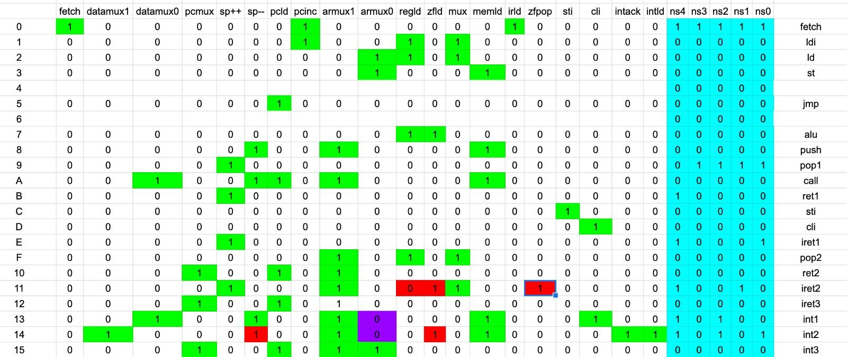

Instruction Set

LD
Load instruction transfers
- the contents of a memory location (which is a 16-bit number)
- into a register of Reptile.
The assembly format of the Load instruction is as follows:
LD r1 r2
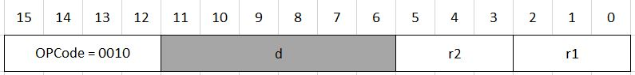

LDI
LDI r,x
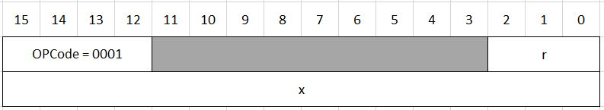

ALU Instructions

Instruction Format

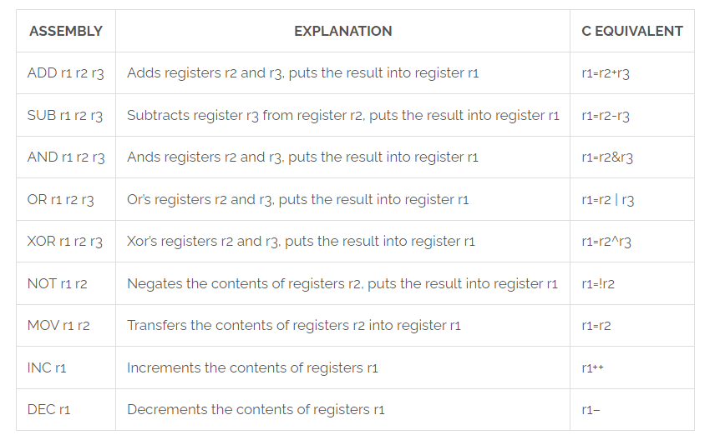

ALU Codes

Instruction | ALU CODE | ALU CODE (Circuit) | ALU CODE
ADD | 0000 | 000000 | 0
SUB | 0001 | 001000 | 16
AND | 0010 | 010000 | 32
OR | 0011 | 011000 | 48
XOR | 0100 | 100000 | 64
NOT | 0101 | 000101 | 3
MOV | 0110 | 000110 | 6
INC | 0111 | 000111 | 7
DEC | 1000 | 001000 | 8

INC
INC r1
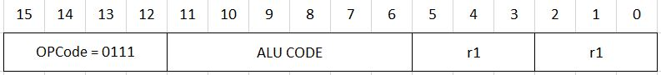

DEC
DEC r1

MOV
MOV r1 r2
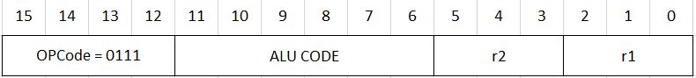

NOT
NOT r1 r2

ADD, SUB, AND, OR, XOR
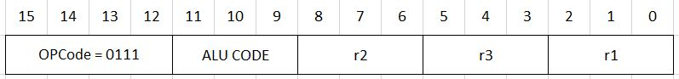

JUMP
JMP instruction is unconditional: it always jumps to the given target location within the code
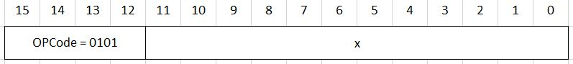

JZ
JZ instruction is conditional: it jumps to the given target location within the code only if the result of the last ALU instruction is zero. Otherwise, the next instruction in the program is executed.
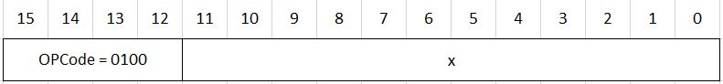

ST
Store instruction stores
- The contents of a register
- Into a memory location, which is pointed by another register.
The assembly format of the Store instruction is as follows:
ST r1 r2
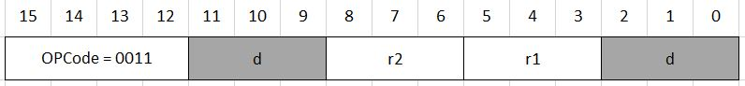
Here r1 and r2 are two-bit fields denoting two registers:
- r1 is a register which “points” to memory: It contains the address of the memory location to which the data is to be loaded .
- r2 is the register which contains the data to be stored in memory.

PUSH
Assembly format: Push r
Writes the contents of the register r into the memory location pointed by the SP. Then decrements SP by one.
Machine code format:
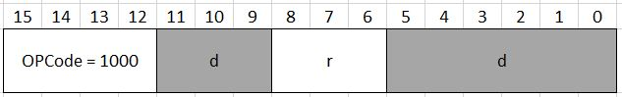

POP
Assembly format: Pop r
Pop increments SP by 1, then transfers the content of the memory location pointed by SP into register r.
Machine code format:
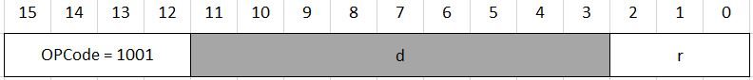

CALL
Assembly format: Call x
Pushes the content of the Program Counter (PC) into the stack and jumps to memory address PC+x, i.e, loads the number PC+x into PC. (PC<=PC+x). Recall that PC is already incremented when we start to execute the Call instruction.
Machine code format:
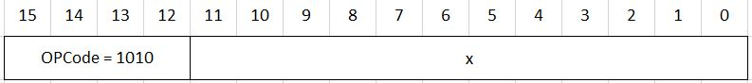

RET
Assemby format: Ret
Pops the top of the stack into PC.
Machine code format:
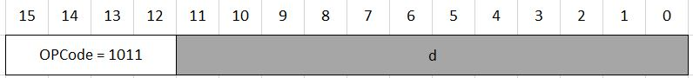

IRET
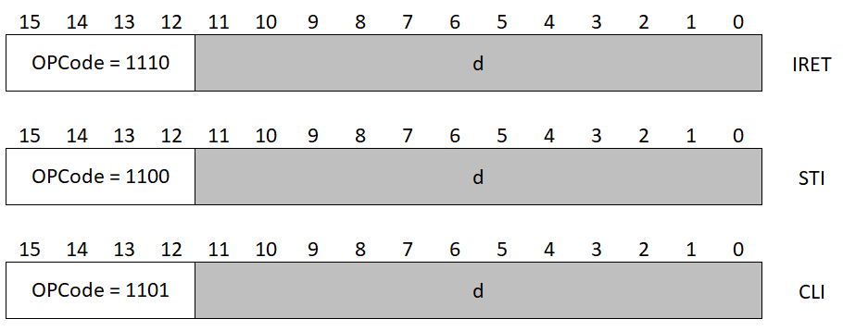

STI

CLI

Bird

Finite State Machine
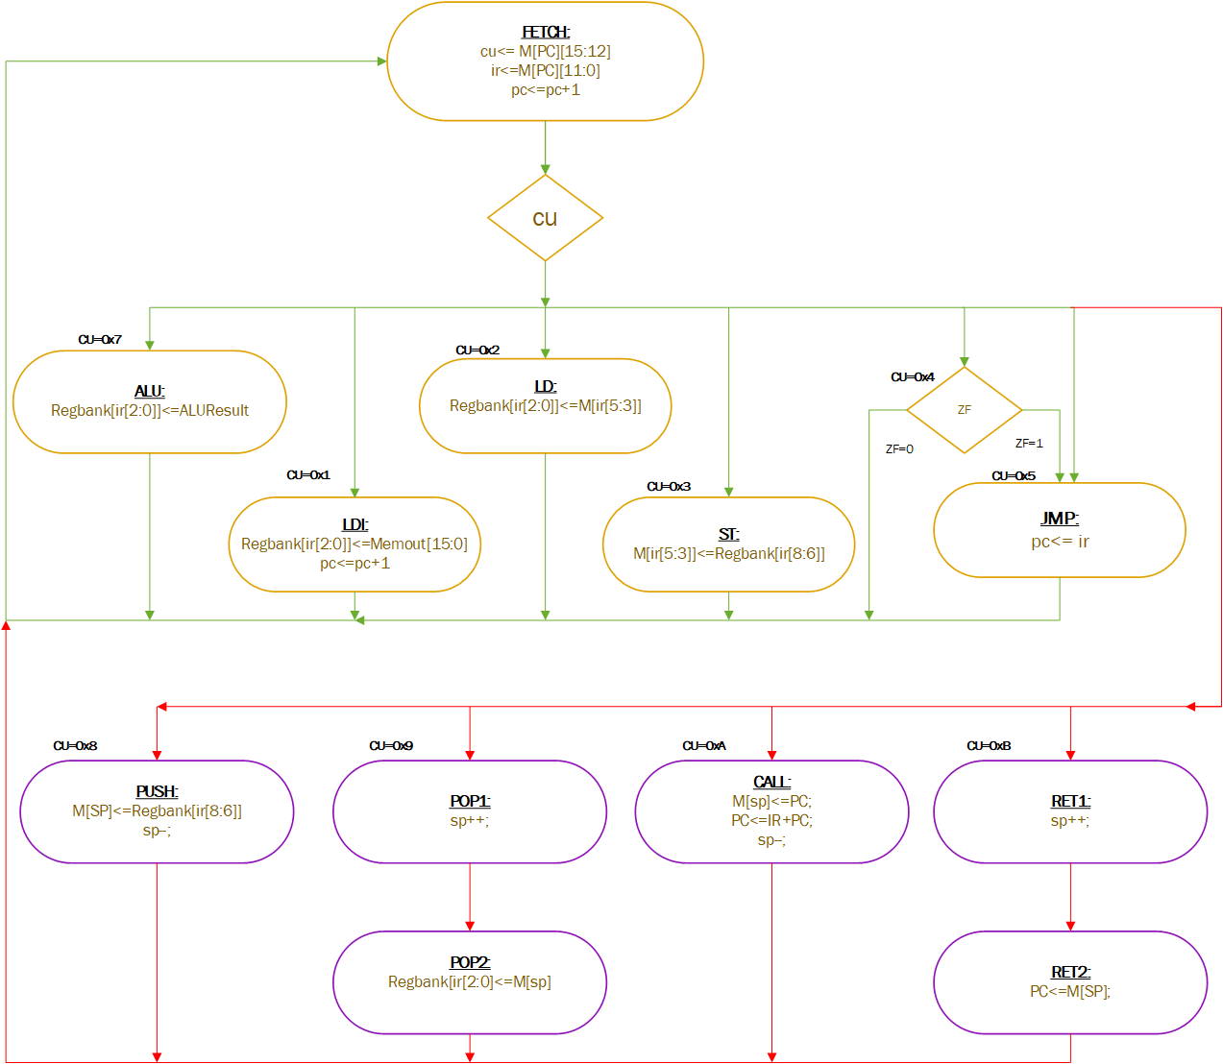

Hardware Design
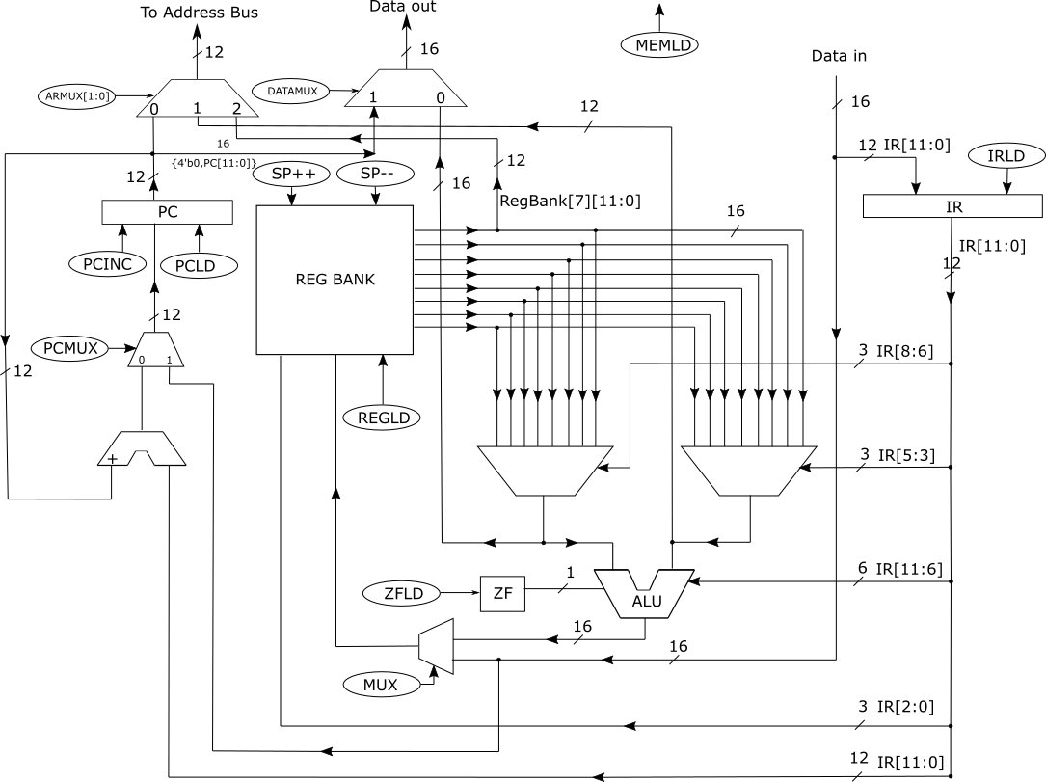

Control Unit Connection
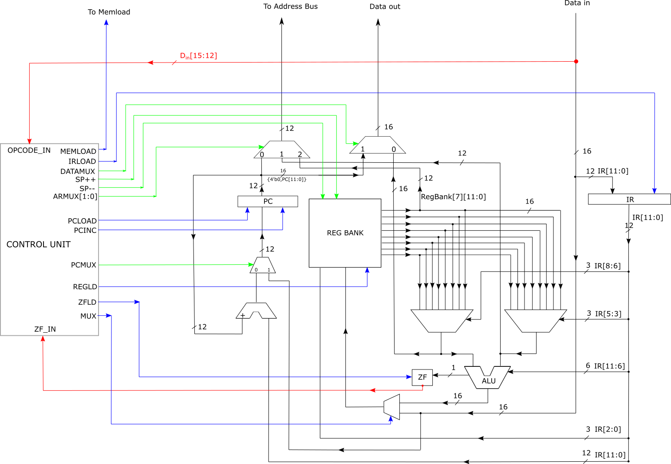

Control Unit Interior
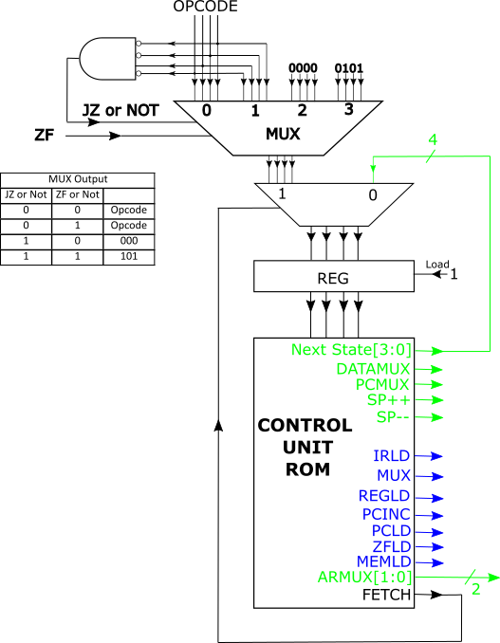

Control Signals
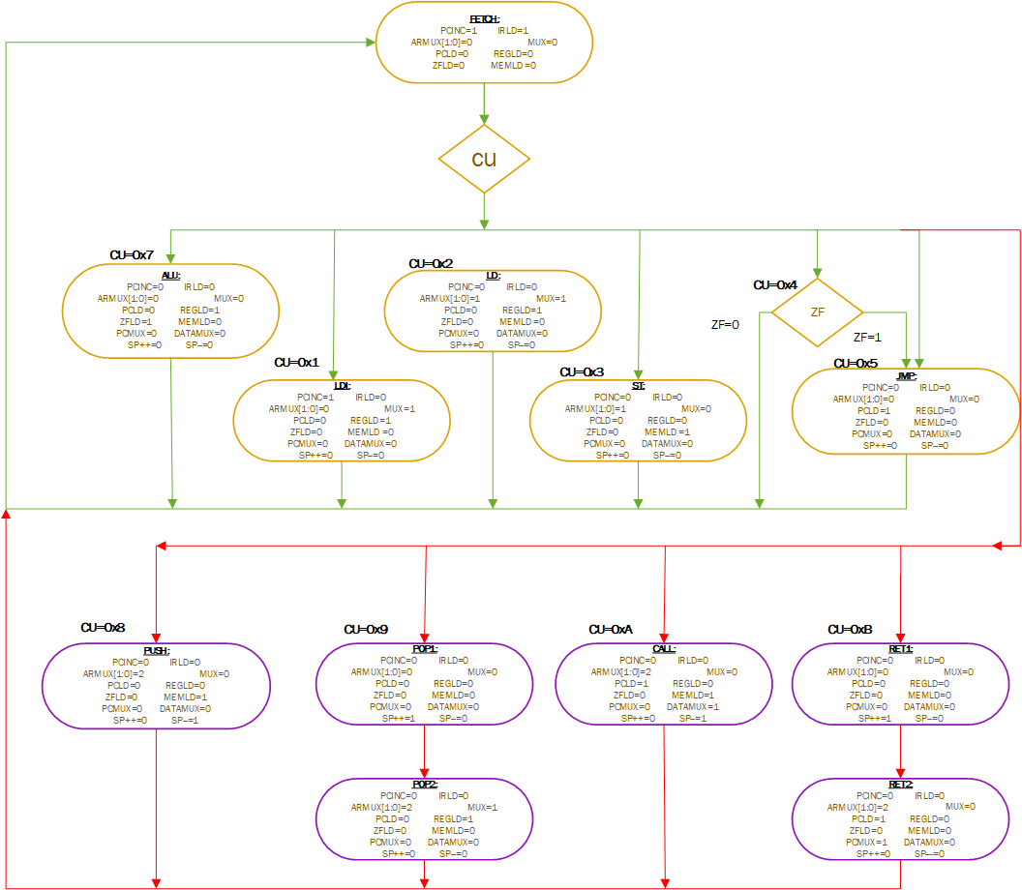

Microcode
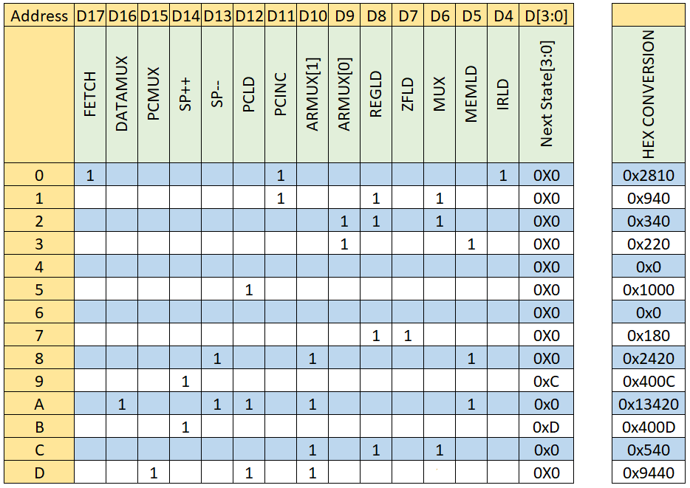

Register Bank
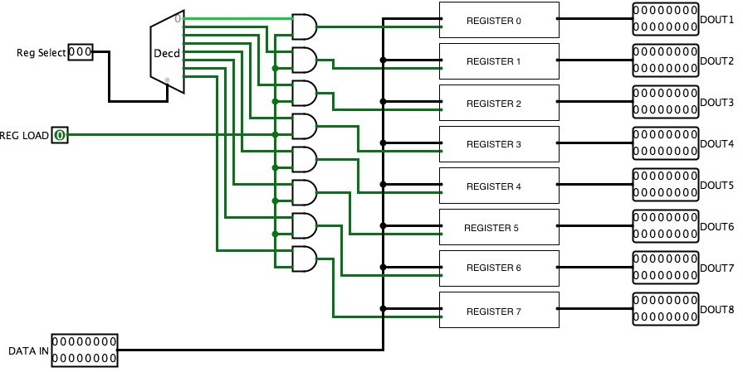

Verilog
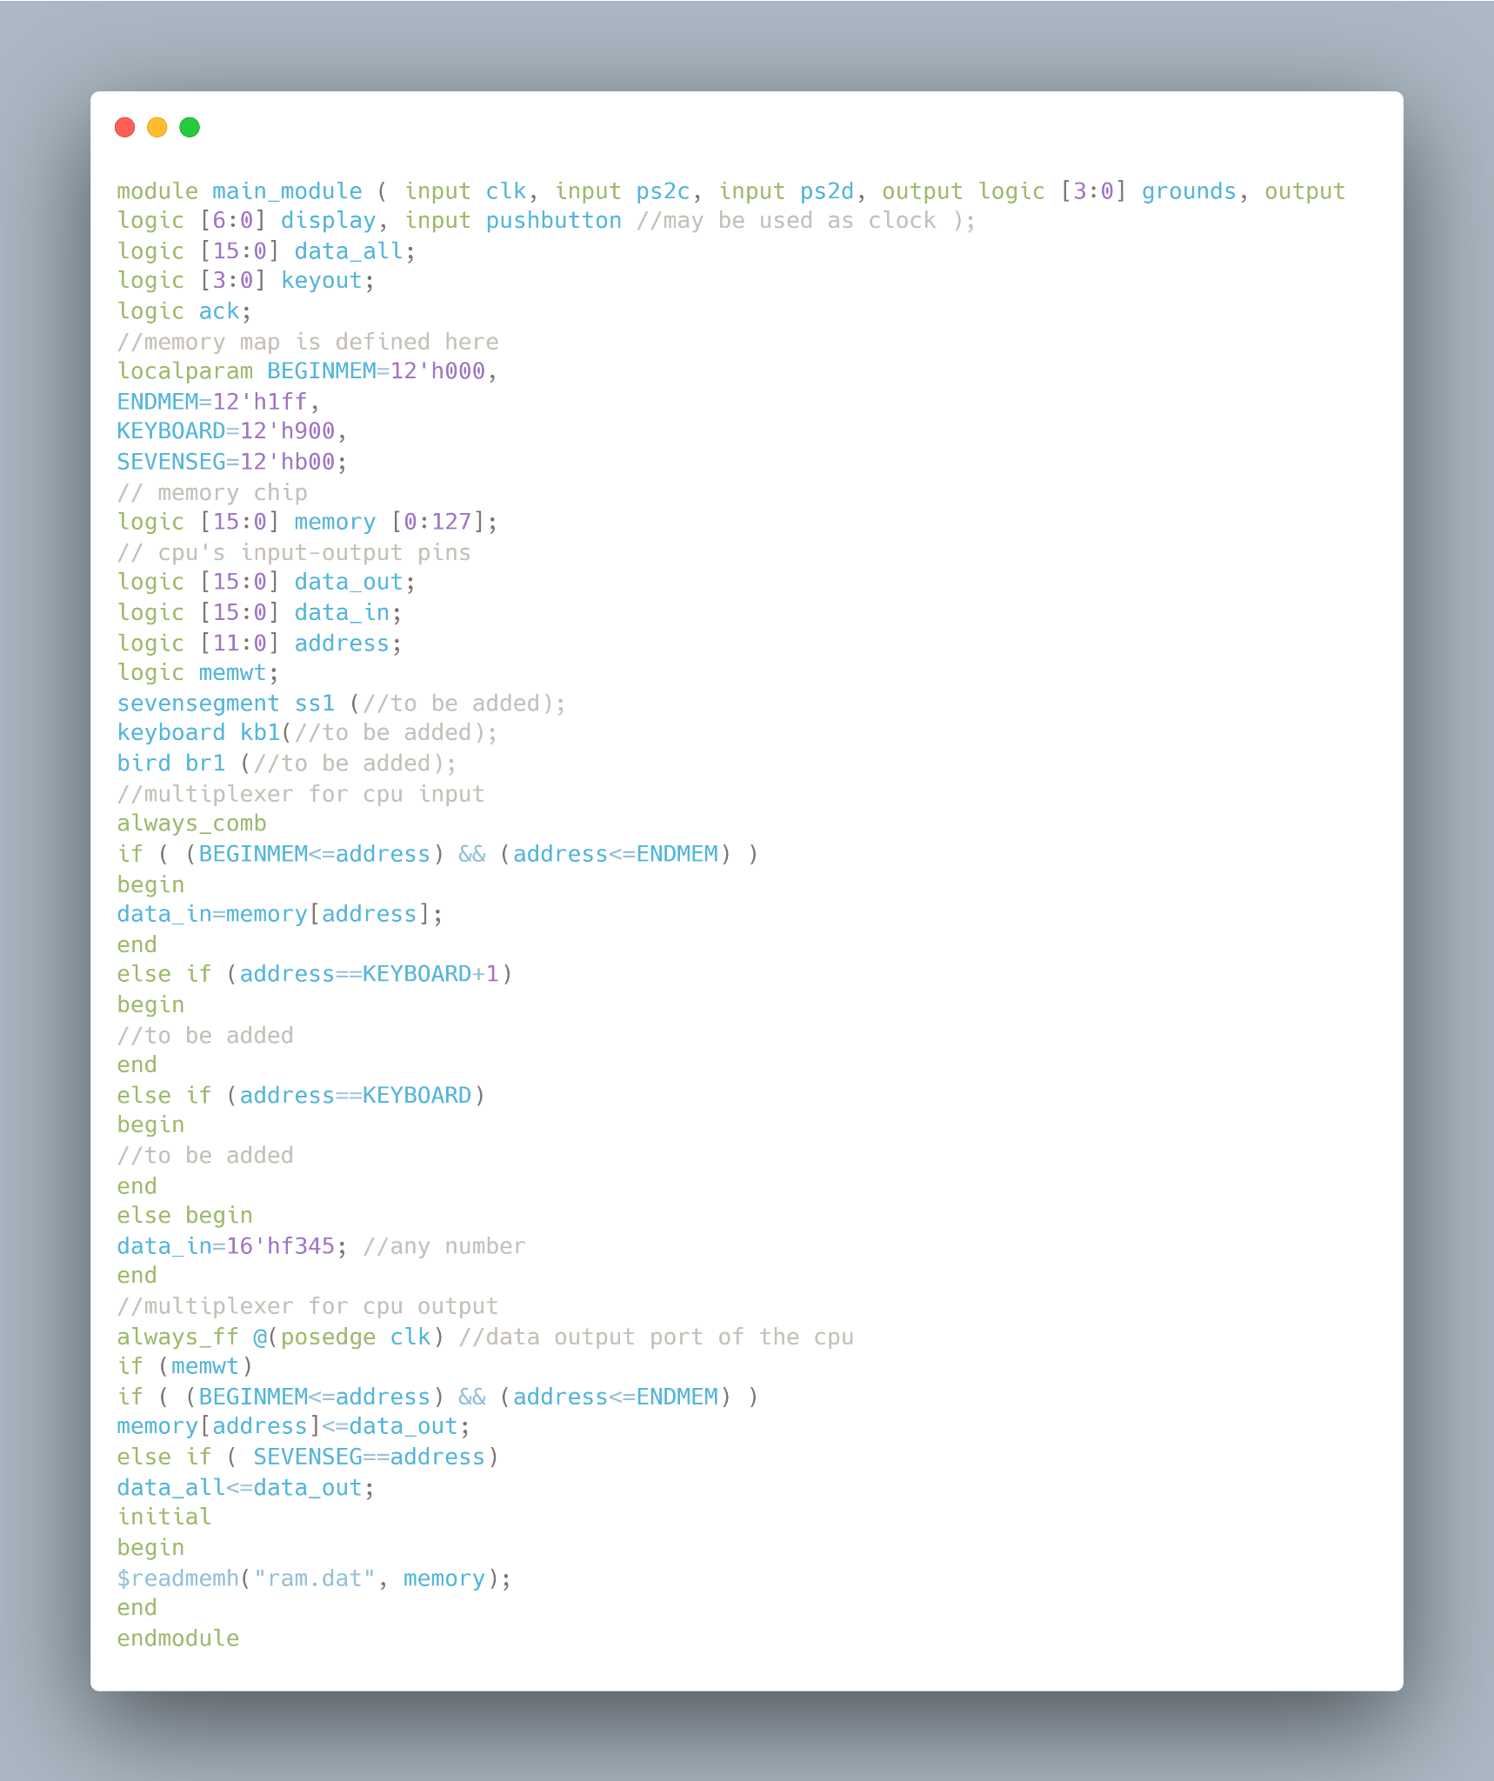

Reptile

Verilog

CPU
//Reptile design with 8 Registers.
// This module also sends register #0 to main module as an output
module reptile (
input clk,
input [15:0] data_in,
output [15:0] data_out,
output logic [11:0] address,
output memwt,
output [15:0] reg0
);
logic [11:0] pc, ir; //program counter, instruction register
logic [4:0] state; //FSM
logic [15:0] regbank [7:0];//registers
logic zeroflag; //zero flag register
logic [15:0] result; //output for result
localparam FETCH=4'b0000,
LDI=4'b0001,
LD=4'b0010,
ST=4'b0011,
JZ=4'b0100,
JMP=4'b0101,
ALU=4'b0111;

logic zeroresult; //zeroflag value
always_ff @(posedge clk)
case(state)
FETCH:
begin
if ( data_in[15:12]==JZ) // if instruction is jz
if (zeroflag) //and if last bit of 7th register is 0 then jump to jump instruction state
state <= JMP;
else
state <= FETCH; //stay here to catch next instruction
else
state <= data_in[15:12]; //read instruction opcode and jump the state of the instruction to be read
ir<=data_in[11:0]; //read instruction details into instruction register
pc<=pc+1; //increment program counter
end
LDI:
begin
regbank[ ir[2:0] ] <= data_in; //if inst is LDI get the destination register number from ir and move the data in it.
pc<=pc+1; //for next instruction (32 bit instruction)
state <= FETCH;
end
LD:
begin
regbank[ir[2:0]] <= data_in;
state <= FETCH;
end
ST:
begin
state <= FETCH;
end
JMP:
begin
pc <= pc+ir;
state <= FETCH;
end
ALU:
begin
regbank[ir[2:0]]<=result;
zeroflag<=zeroresult;
state <= FETCH;
end
endcase
always_comb
case (state)
LD: address=regbank[ir[5:3]][11:0];
ST: address=regbank[ir[5:3]][11:0];
default: address=pc;
endcase
assign memwt=(state==ST);
assign data_out = regbank[ir[8:6]];
always_comb
case (ir[11:9])
3'h0: result = regbank[ir[8:6]]+regbank[ir[5:3]]; //000
3'h1: result = regbank[ir[8:6]]-regbank[ir[5:3]]; //001
3'h2: result = regbank[ir[8:6]]&regbank[ir[5:3]]; //010
3'h3: result = regbank[ir[8:6]]|regbank[ir[5:3]]; //011
3'h4: result = regbank[ir[8:6]]^regbank[ir[5:3]]; //100
3'h7: case (ir[8:6])
3'h0: result = !regbank[ir[5:3]];
3'h1: result = regbank[ir[5:3]];
3'h2: result = regbank[ir[5:3]]+1;
3'h3: result = regbank[ir[5:3]]-1;
default: result=16'h0000;
endcase
default: result=16'h0000;
endcase
assign zeroresult = ~|result;
assign reg0=regbank[0];
initial begin;
state=FETCH;
zeroflag=0;
pc=0;
end
endmodule

